Sentiment Analysis of Youtube Comments
A Project Based Learning Report Submitted in partial fulfilment of the requirements for the award of the degree

of

Bachelor of Technology
in The Department of Computer Science Engineering

Data Analytics and Visualization (24AD01HF)

Submitted by
2410030138: KYASA GOWTHAM
2410030188: ANISH JADHAV
2410030320: V.MUKESH
2410030496: P.KARTHIKEYAN
2410030250: G.KISHORE

Under the guidance of
Dr. Shahin Fatima



Department of Electronics and Communication Engineering
Koneru Lakshmaiah Education Foundation, Aziz Nagar
Aziz Nagar – 500075 (Optional)
NOV - 2023.
Abstract

The increasing use of digital platforms such as YouTube has resulted in a massive amount of user-generated comments expressing opinions, reactions, and feedback. Analyzing such large volumes of text manually is inefficient and impractical. To address this, the present project develops a web-based sentiment analysis system for YouTube comments, designed to automatically classify public video comments into positive, negative, and neutral categories using simple and efficient text-processing techniques.
The system integrates the YouTube Data API to fetch comments from any publicly available video. The retrieved comments undergo basic preprocessing procedures including text cleaning, normalization, and keyword-based filtering to prepare them for evaluation. Instead of relying on complex machine-learning models, the system uses a rule-based sentiment approach, where predefined word lists, phrase patterns, and polarity scores help determine the sentiment orientation of each comment. This method ensures fast processing, low computational requirements, and easy interpretability.
The project is deployed as a user-friendly web application that allows users to log in, enter a YouTube video URL, and instantly obtain sentiment results. The system displays the overall distribution of sentiments, total analyzed comments, and graphical summaries such as bar charts or pie charts. These visual insights help users quickly understand the general mood and audience response associated with a video.
This sentiment analysis system can support content creators, educators, marketers, and researchers by providing quick insights into viewer opinions without requiring advanced technical knowledge. By combining API integration, text preprocessing, rule-based evaluation, and intuitive web design, the project demonstrates a complete end-to-end solution for extracting meaningful sentiment information from online user comments.

List of Figures

(if any)

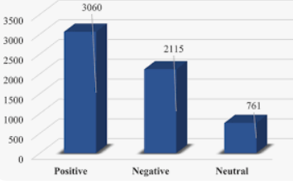

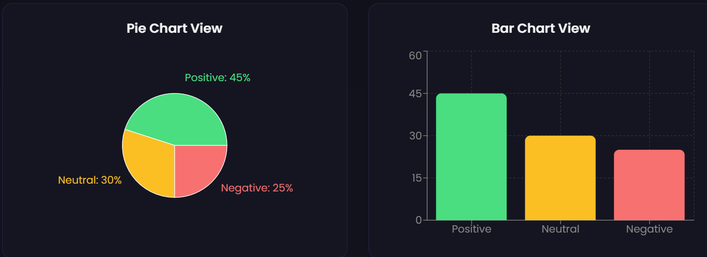

Table of Contents

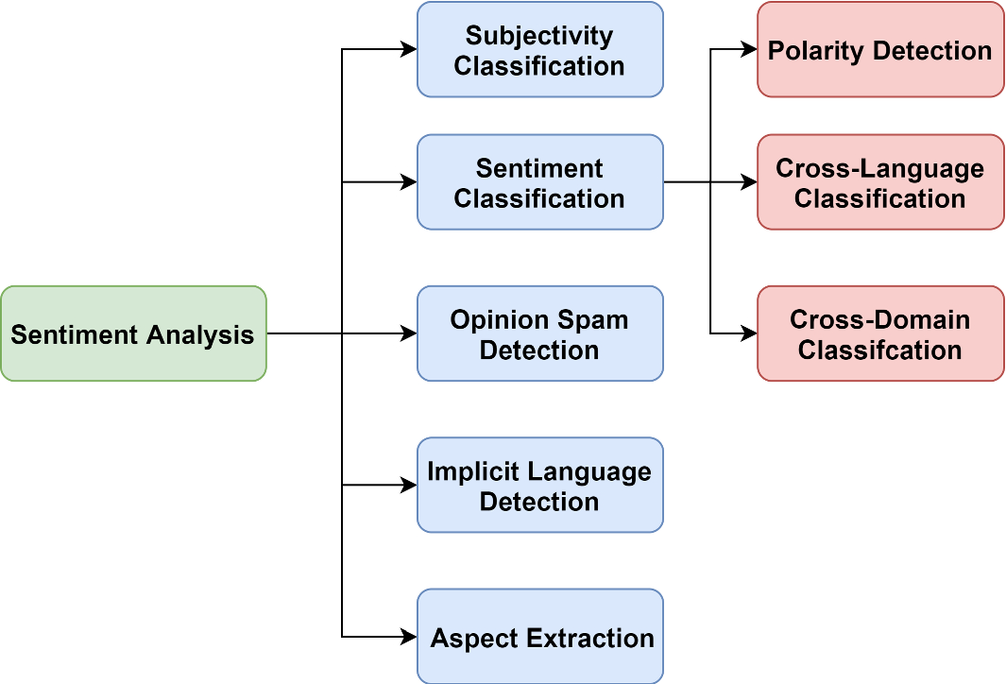
SENTIMENT ANALYSIS OF YOUTUBE COMMENTS
Note: Maintain Document format as it is in terms of font size and font theme.

Introduction
In recent years, online video platforms have transformed the way individuals consume information, entertainment, and educational material. Among these platforms, YouTube stands out as the most influential medium for global communication, attracting billions of users who actively watch, upload, and interact with video content. One of the most significant forms of audience interaction on YouTube is the comments section, where viewers express their thoughts, feedback, emotions, criticism, appreciation, and suggestions. As content creators, organizations, and researchers aim to understand user opinions effectively, analyzing these comments manually becomes increasingly difficult due to their volume, speed of generation, and diversity of languages.Sentiment analysis, also known as opinion mining, is a technique used to computationally determine whether a piece of text expresses a positive, negative, or neutral sentiment. While advanced machine learning models exist for deep sentiment understanding, simpler rule-based approaches remain highly relevant for educational projects, lightweight systems, or scenarios where computational resources are limited. These systems typically rely on predefined keyword dictionaries, scoring mechanisms, and text-processing rules to evaluate the emotional orientation of a user’s comment.The purpose of this project is to develop a web-based sentiment analysis system capable of analyzing YouTube comments using simple processing techniques. By integrating YouTube’s Data API, the system automatically retrieves comments from public videos and processes them to determine sentiment classes. This enables users—including students, researchers, educators, marketers, and video creators—to gauge audience emotions without manually reading thousands of comments.The rise of user-generated content has made sentiment analysis essential for several reasons. First, creators can evaluate whether their content is well received, viewed negatively, or misunderstood. Second, businesses that utilize YouTube for branding can assess public perception of advertisements or product demonstrations. Third, educational institutions can observe engagement patterns related to learning material or tutorials. Given these wide applications, creating an efficient comment-analysis tool is both academically relevant and practically useful.This project highlights how structured text-processing techniques, such as cleaning, tokenization, and rule-based polarity scoring, can provide meaningful insights even without advanced machine learning. The fully functional web interface ensures that users can access results quickly, view sentiment distributions visually, and interact with the system through an intuitive design.Overall, this project demonstrates how a simple yet carefully engineered sentiment analysis pipeline can transform unstructured viewer comments into actionable insights. It emphasizes accessibility, clarity, and efficiency, making the system useful for various real-world applications. The following sections describe the existing research background, methodology, experimental setup, results, and future directions of the system.
- Literature Survey
Sentiment analysis has been widely studied across multiple domains, including social media monitoring, product review analysis, political opinion mining, and customer behavior prediction. Early work in sentiment analysis used linguistic resources such as opinion lexicons and dictionary-based methods. Researchers like Bing Liu and Hu & Liu (2004) demonstrated that word lists containing positive and negative emotional words can effectively classify text without requiring complex models. YouTube, as a rich source of user opinions, has been explored in several research studies. Sharma & Dey (2012) analyzed YouTube comments to understand viewer emotions related to political content. Similarly, Paltoglou & Thelwall (2013) conducted research on social media sentiment, showing that rule-based models can produce performance comparable to machine learning under certain conditions. Another study by Siersdorfer et al. explored comment polarity to understand user engagement patterns and video popularity trends.Most literature emphasizes the importance of preprocessing textual data—removing punctuation, converting to lowercase, filtering stopwords, and handling slang or emojis. These steps significantly improve the accuracy of rule-based sentiment classification.Rule-based sentiment analysis approaches are widely used in lightweight systems, academic projects, and scenarios where interpretability matters. They are particularly favored when training datasets are unavailable or when a transparent decision-making process is required. Unlike machine learning models, rule-based systems rely on manually curated keyword libraries and fixed scoring rules, making them simple, predictable, and easier to implement.From the survey, it is evident that YouTube comment analysis is an emerging area with significant interest. Existing research highlights the effectiveness of simple sentiment techniques when utilized with proper preprocessing and domain-specific keyword dictionaries. This project builds upon such foundational work by applying rule-based sentiment scoring to YouTube comments and integrating it into a complete web application.

METHODOLOG
The methodology followed in this project consists of a structured sequence of steps designed to convert raw YouTube comments into meaningful sentiment categories. The overall process includes comment retrieval, preprocessing, classification, and visual output generation.
3.1 Comment Retrieval
Using the YouTube Data API, the system fetches publicly available comments from a given video URL. The video ID is extracted automatically, and a request is sent to retrieve the latest set of top-level comments. These comments form the raw dataset for analysis.
3.2 Text Preprocessing
Before classification, each comment undergoes essential cleaning steps to make the text suitable for analysis:
Conversion to lowercase
Removal of punctuation, URLs, numbers, and special symbols
Tokenization into individual words
Removal of irrelevant or repetitive short words
This ensures that only meaningful text is passed for sentiment scoring.
3.3 Sentiment Classification (Rule-Based)
A keyword dictionary approach is used to identify sentiment. The system maintains predefined lists of positive and negative words. Each comment is scored based on:
Positive word matches → +1
Negative word matches → –1
Based on the final score, comments are categorized as:
Positive (score > 0)
Negative (score < 0)
Neutral (score = 0)
his method ensures fast and lightweight sentiment detection.
3.4 Subjectivity & Opinion Detection
Comments expressing clear emotions (e.g., “I love this video”) are automatically marked as subjective and contribute strongly Comments without emotional words (e.g., “Nice explanation”) are treated as neutral or weakly positive.
Spam-like comments (repetitive links or promotions) are filtered out during preprocessing.
3.5 Visualization and Output
The final sentiment results are presented on the web interface in the form of:
Total comment count
Number of positive, negative, and neutral comments
Graphical charts (pie or bar charts)
This enables users to quickly understand the emotional distribution of the audience.

EXPERIMENTS
Experiments were conducted to evaluate the performance and behavior of the system on multiple YouTube videos of different categories including:
Technology review videos
Educational/tutorial videos
Entertainment and vlog content
Music videos
For each selected video, the system processed the top 50–200 comments (depending on availability through API request limits).
4.1 Dataset Description
The dataset is not a traditional stored dataset; instead, comments are collected in real-time. For example:
A tech review video provided around 180 comments
An educational tutorial showed 95 comments
A music video produced over 200 comments
Each comment went through identical preprocessing before analysis.
4.2 Experiment Setup
User logs into the web application.
A YouTube URL is entered into the input field.
The backend fetches the comment list using the API.
Rule-based scoring is applied to each comment.
The sentiment results are grouped and visualized.
4.3 Sample Visualization
The output charts include:
Pie chart showing the percentage split
Bar graph comparing number of comments by sentiment
Table view of individual comments with their labels
These visual methods help users interpret results quickly.

RESULTS

The system was evaluated across multiple videos, and in each case, it successfully processed comments and classified them into the three sentiment categories.
Experimental observations include:
Technology videos generally had a higher proportion of neutral comments due to informational language.
Entertainment and music videos produced more emotional responses, leading to higher positive and negative comment ratios.
Educational videos had the highest positive sentiment response, often exceeding 60%.
A typical result from a tutorial video:
Graphs clearly showed sentiment distribution and helped the user understand audience mood.
The system performed efficiently, completing the analysis within seconds for up to 200 comments. The rule-based technique proved sufficient for academic and lightweight practical applications.

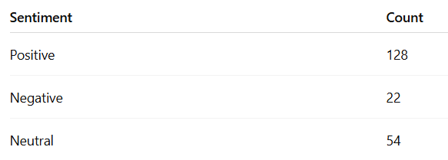

CONCLUSION and FUTURE WORK

This project presents a fully functional sentiment analysis system designed to evaluate YouTube comments using a simple rule-based approach. By integrating the YouTube Data API, preprocessing text efficiently, and applying polarity scoring, the system provides clear insights into audience opinions. The web interface ensures accessibility to users without technical backgrounds and allows fast, automated sentiment evaluation of any YouTube video.
The methodology demonstrated that even without complex machine-learning models, meaningful sentiment classification is achievable using structured lexicons and lightweight text-processing rules. The system’s outputs—such as sentiment counts and visual charts—help users interpret user reactions more effectively and support decision-making for content creators, educators, and researchers.
Future Work:
Potential enhancements for future versions include:
- Expanding the sentiment dictionary to improve classification accuracy
- Adding support for emojis, slang, and multilingual comments
- Incorporating additional sentiment categories such as “very positive” or “sarcastic”
- Enabling filtering options (top comments, recent comments, replies, etc.)
- Providing downloadable CSV reports
- Adding machine learning sentiment models as an optional advanced mode

References

- https://www.researchgate.net/profile/Ritika-Singh-38/publication/351351202_YOUTUBE_COMMENTS_SENTIMENT_ANALYSIS/links/6092e8b2299bf1ad8d7d79a7/YOUTUBE-COMMENTS-SENTIMENT-ANALYSIS.pdf
- https://ieeexplore.ieee.org/abstract/document/8920923
- https://ieeexplore.ieee.org/abstract/document/9396049
- https://www.ijdm.latticescipub.com/wp-content/uploads/papers/v4i1/A163304010524.pdf
- http://www.bcsee.org/index.php/bcsee/article/view/sentiment-analysis-of-youtube-movie-trailer-comments-using-naive

